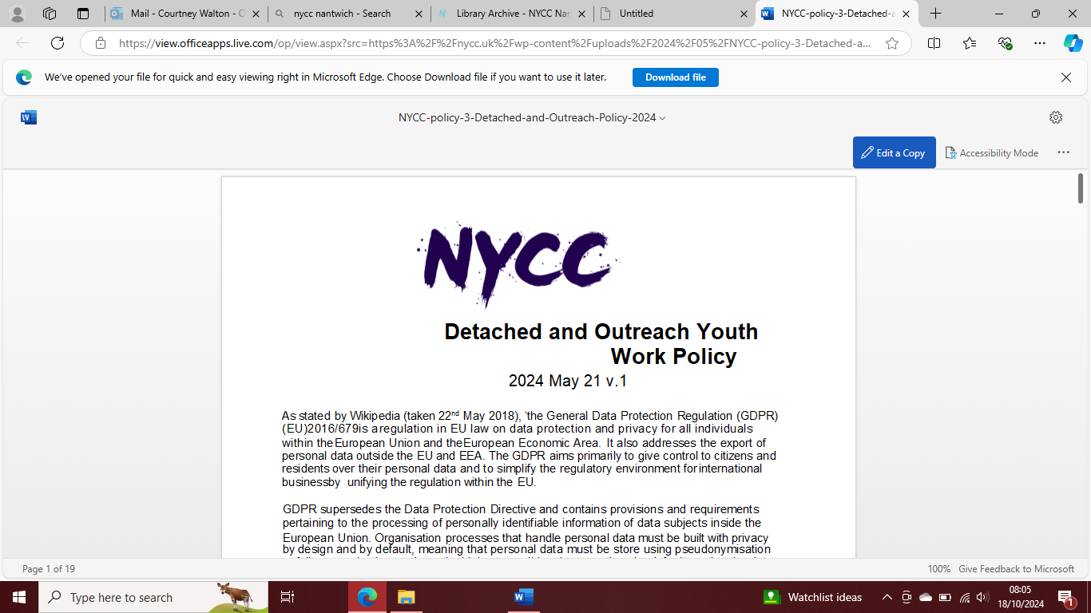
VOLUNTEER APPLICATION FORM - CONFIDENTIAL
All applicants for volunteer roles will be asked to complete an application form to help us understand a bit more about you and why you want to volunteer with us. You will be required to undergo a DBS check and when allocated, complete up to date safeguard training, unless you already hold an in date current certificate. We will require a copy of your passport, driving license or other form of ID such as birth certificate (not photocopied) and utility bill/council tax/letter from college/principle etc
If you have any questions, please ask Leah Austin Garratt.
hello@nycc.uk
Thank you for wanting for volunteer with NYCC Nantwich.
SECTION A: Your personal details
Title:
First Name:
Surname/ Last Name:
Any previous names by which you have been known:
Address (Please include postcode):
How long have you lived at the above address?
If less than 12 months, please give your previous address (including postcode):
How long did you live there? years and months

SECTION B:
Why do you want to volunteer with NYCC? Please include information about any skills or experience you hope to gain through volunteering.
SECTION C:
Please give details of any previous experience you may have of looking after and/or working with children and young people.
SECTION D:
Please give details of any relevant qualifications, training and/or personal qualities which you feel equip you to work with children and young people.
SECTION E:
You’re availability to volunteer?
Day | Choice
Tuesday
Wednesday
Friday

How often? | Choice
Weekly
Fortnightly
Monthly
SECTION F: References
Please give the name and contact details of two suitable referees.
At least one should have knowledge of any previous work you may have undertaken with children and young people.
Name:
Organisation (if applicable):
Address (including postcode):
Telephone No:
In what capacity do you know this person?
Have they consented to us contacting them?
Name:
Organisation (if applicable):
Address (including postcode):
Telephone No:
In what capacity do you know this person?
Have they consented to us contacting them?

SECTION G: Declaration
I confirm that the information I have given in this form is accurate and truthful.
Signed:
Date:

Thank you for completing this application form. Please return it to the name and address given below:
Leah Austin-Garratt
hello@nycc.uk

The information you give us in this form will be treated in the strictest confidence.

